**WEEK – 5**

**1#** Write a program to print the no. of bytes used by the different data type using the sizeof() operator

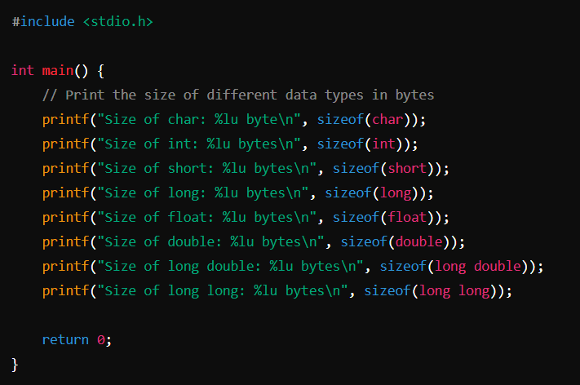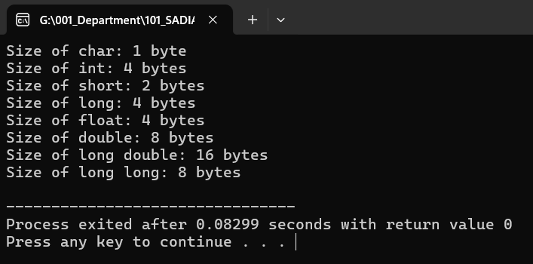

**2#** Develop a flow chart/algorithm and write an interactive program to find Simple Interest and Compound Interest, where Principle, Rate and Time are taken from the keyboard

#### **Flowchart Steps:**

1. **Start**
2. **Input** Principal (P), Rate (R), Time (T)
3. **Calculate Simple Interest (SI)**:
   * Formula: SI = (P * R * T) / 100
4. **Calculate Compound Interest (CI)**:
   * Formula: CI = P * (1 + R/100) ^ T - P
5. **Display** Simple Interest (SI)
6. **Display** Compound Interest (CI)
7. **End**

### **Algorithm for Simple Interest and Compound Interest:**

1. **Start**
2. **Input** Principal (P), Rate (R), and Time (T)
3. **Calculate** Simple Interest:
   * SI = (P * R * T) / 100
4. **Calculate** Compound Interest:
   * A = P * (1 + R/100) ^ T
   * CI = A - P
5. **Output** the Simple Interest (SI) and Compound Interest (CI)
6. **End**

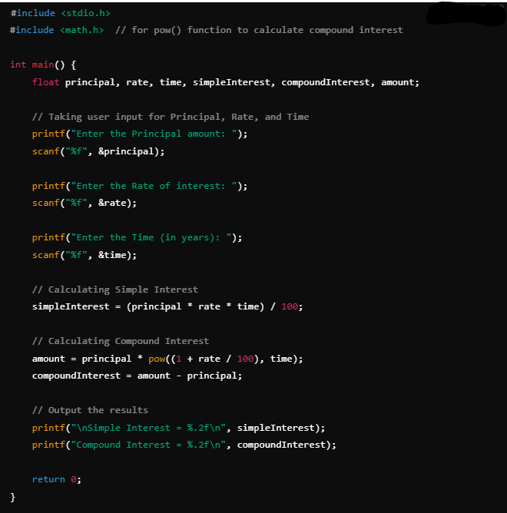

----------------------------------------------------------------------------------------------------------------

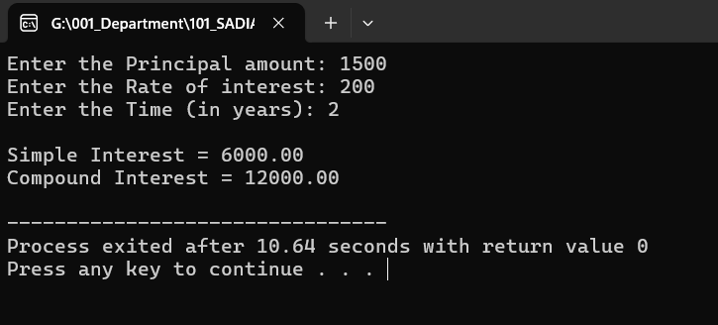

**3#** Develop a flow chart/algorithm and write an interactive program to interchange the value of two variables. Note: - (both ways using temporary variable and not using any other value)

### **Flowchart/Algorithm to Interchange the Values of Two Variables**

#### **Flowchart Steps (Using a Temporary Variable):**

1. **Start**
2. **Input** two variables A and B
3. **Store** the value of A in a temporary variable temp
4. **Assign** the value of B to A
5. **Assign** the value of temp to B
6. Output the values of A and B
7. End

#### **Flowchart Steps (Without Using a Temporary Variable):**

1. **Start**
2. **Input** two variables A and B
3. **Assign** A = A + B
4. **Assign** B = A – B
5. **Assign** A = A – B
6. Output the values of A and B
7. End

### **Algorithm for Interchanging Values Using a Temporary Variable:**

1. **Start**
2. **Input** A and B
3. **Set** temp = A
4. **Set** A = B
5. **Set** B = temp
6. **Output** the new values of A and B
7. **End**

### **Algorithm for Interchanging Values Without Using a Temporary Variable:**

1. **Start**
2. **Input** A and B
3. **Set** A = A + B
4. **Set** B = A – B
5. **Set** A = A – B
6. **Output** the new values of A and B
7. **End**

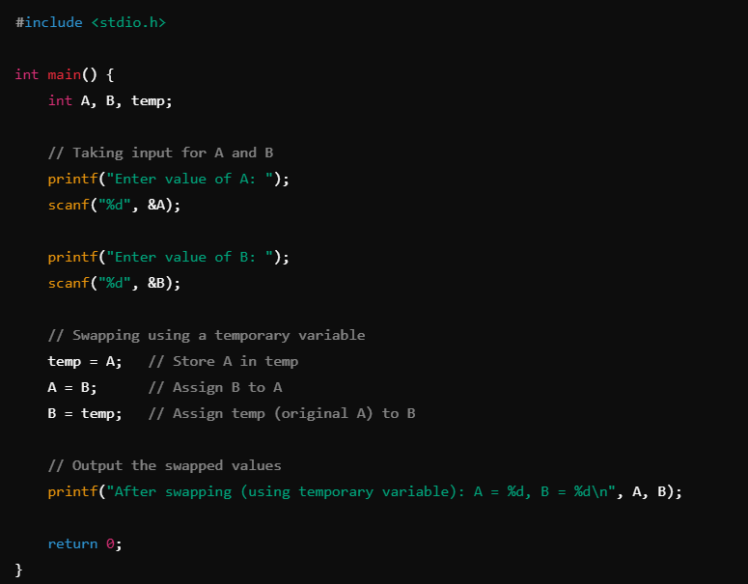

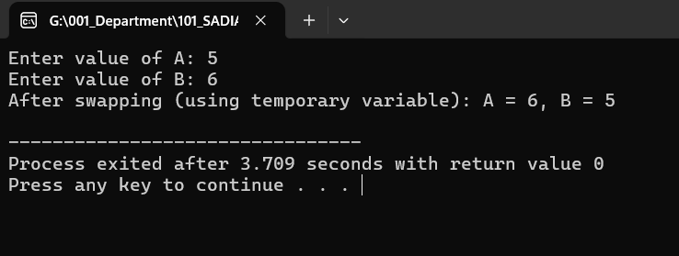

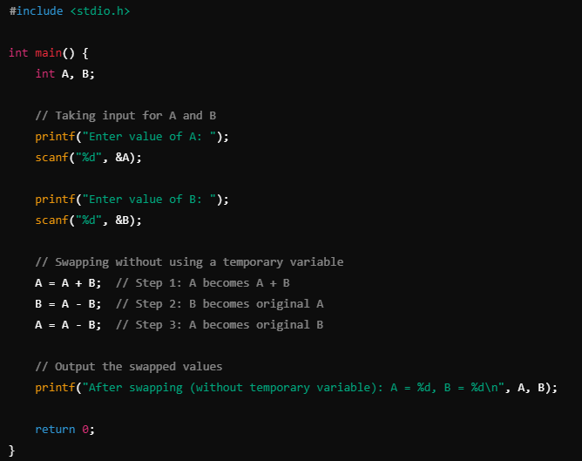

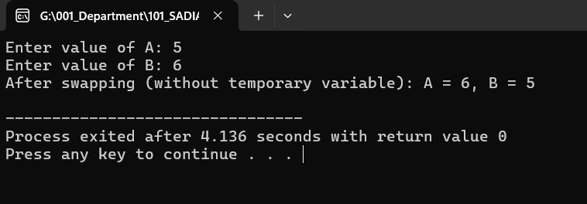

**4#** Write a program in C that reads the length of the three side of a triangle (a, b, c) and determine what type of triangle it is, based on the following cases:

### **Conditions for Determining the Type of Triangle:**

1. **Equilateral Triangle**: All sides are equal (a == b == c).
2. **Isosceles Triangle**: Any two sides are equal (a == b or b == c or a == c).
3. **Scalene Triangle**: All sides are different (a!=b, b!=c, a!=c).
4. **Invalid Triangle**: If the sum of the lengths of any two sides is not greater than the third side, it is not a valid triangle.

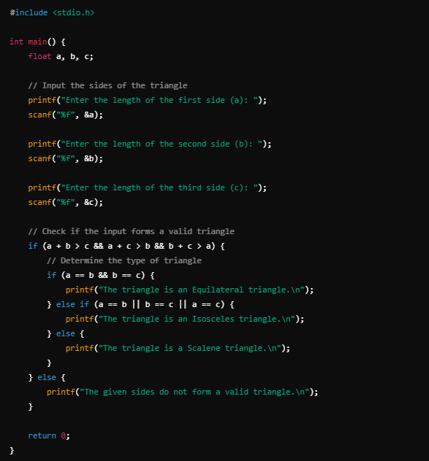

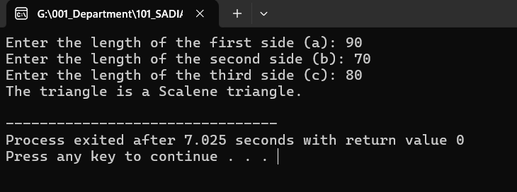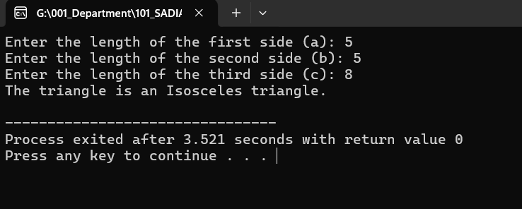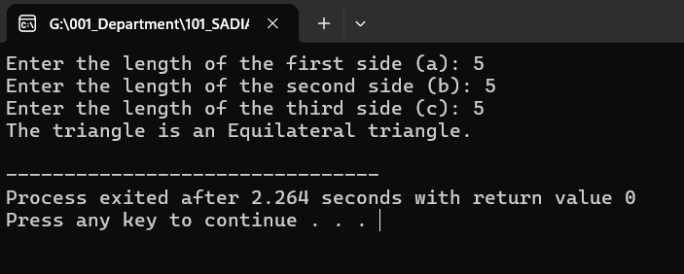

**5#** Write a c Program to find the area and perimeter of the different Shapes

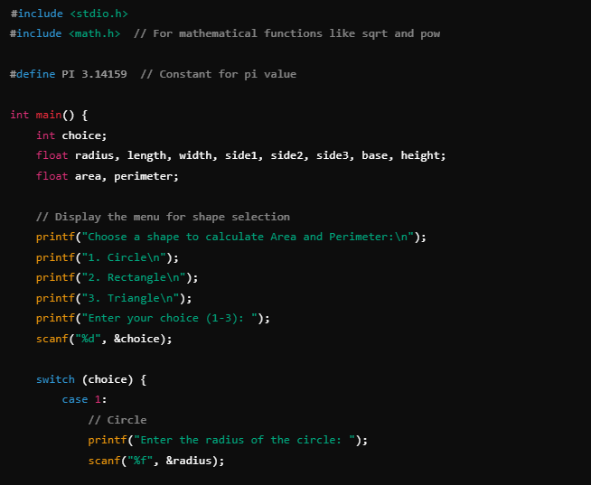

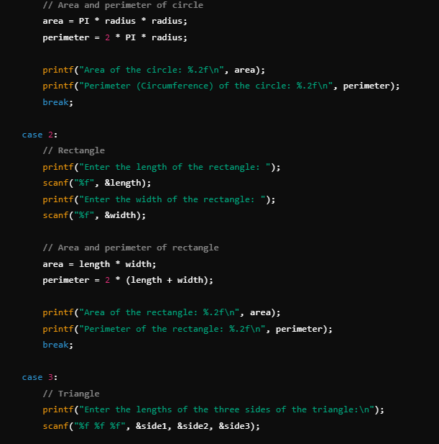

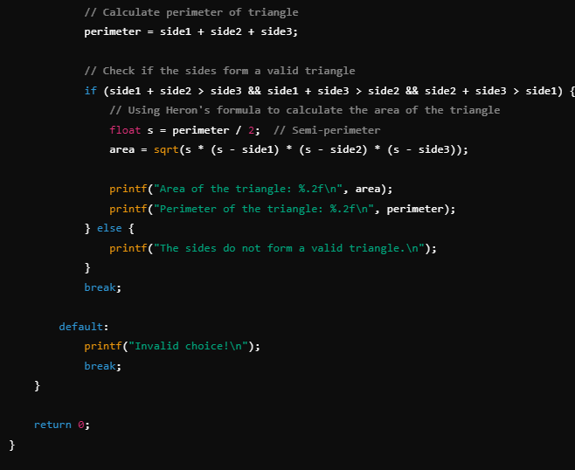

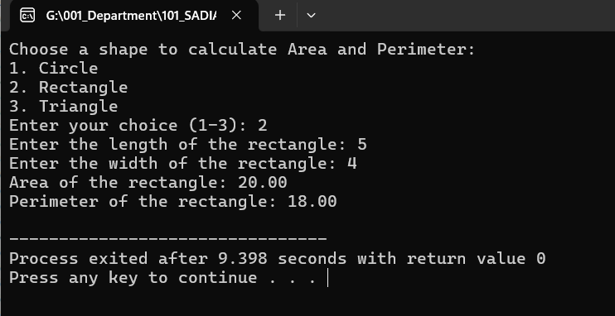

**6#** C Program to find out the ASCII value of a character.

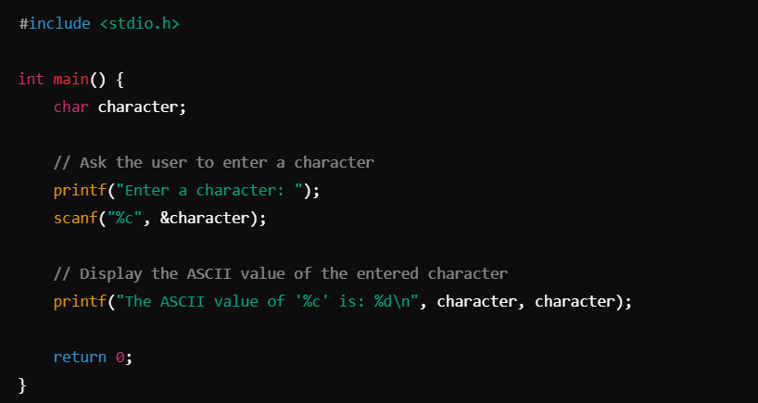

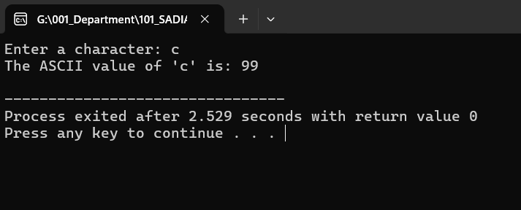

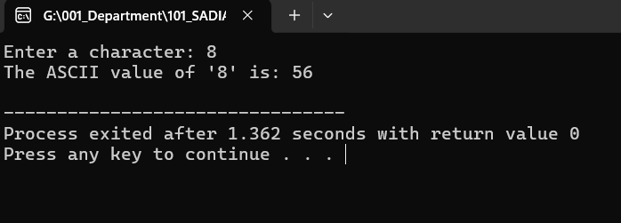

**7#** C Program to check whether an alphabet is vowel or consonant.

